Name- Anmol Gupta

Roll no.- 2110990211

Project Report: Cartify - An E-commerce Website(HTML, CSS, JS and Bootstrap)

Submitted to - Lavish Arora Sir

#OVERVIEW

Cartify took nearly 4 days to come to its completion. It was full of challenges especially about the layout of the webpage and how to make the site responsive for all types of devices. I used 4 different kinds of programming languages namely HTML, CSS, JS and Bootstrap.   
There are about 3600 lines of HTML code, about 2700 lines for styling(CSS) and around 400 lines for JavaScript. It is a light weight website and hence takes less time to load.

1. Introduction:  
Cartify is an e-commerce website that has been developed using HTML, CSS, and JavaScript. The main objective of this project is to provide users with a seamless online shopping experience. The website allows customers to browse and purchase products from various categories, add them to the cart, and proceed to checkout for payment. Cartify also includes features such as user registration, product search, and order tracking.

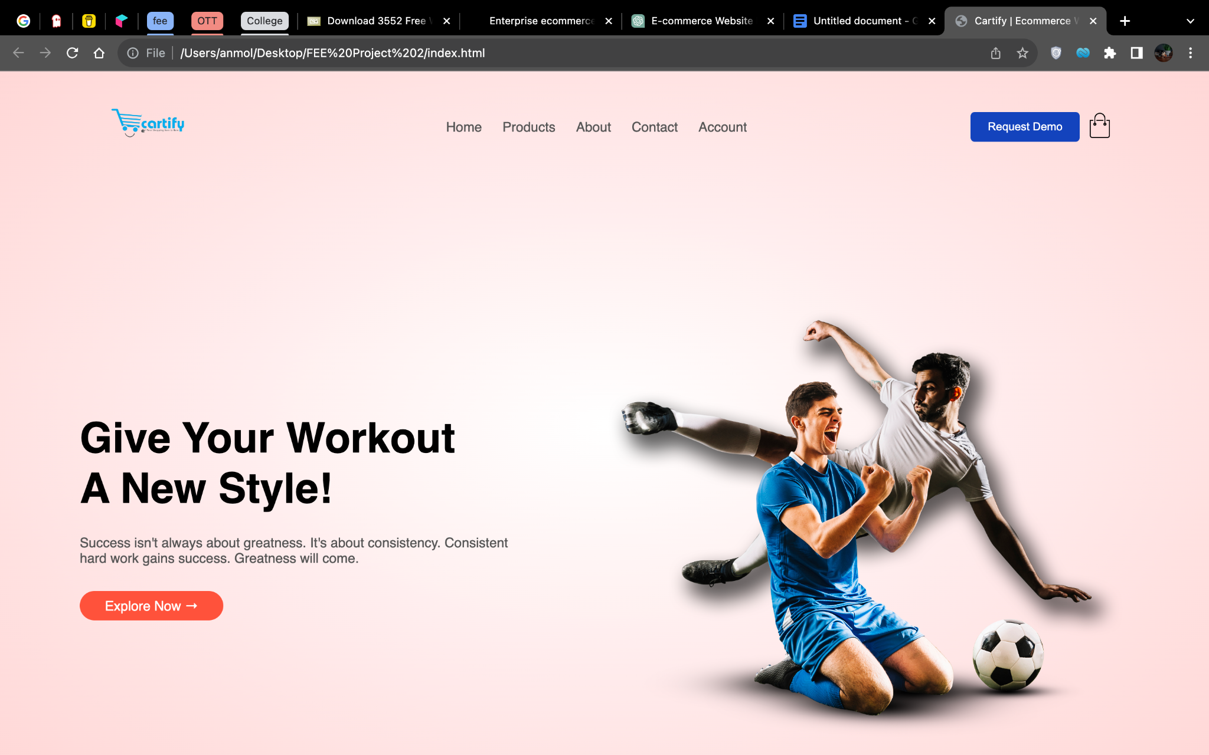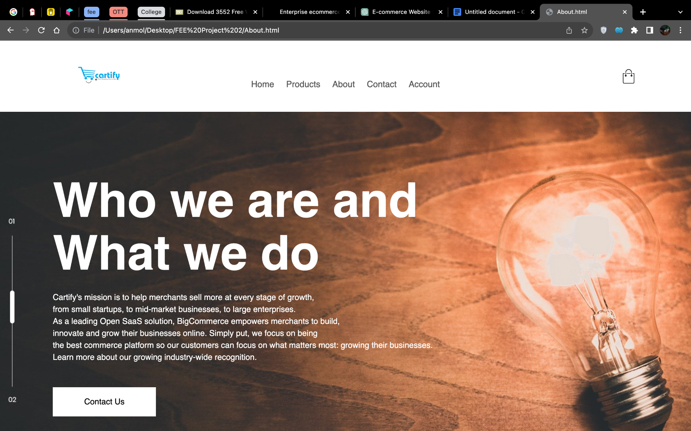

2. Project Scope:  
The scope of this project involved designing and developing a fully functional e-commerce website using web technologies. The website needed to have an intuitive and user-friendly interface, support multiple product categories, handle user registrations and logins, and facilitate secure online transactions. The project also required implementing responsive design principles to ensure compatibility across different devices.

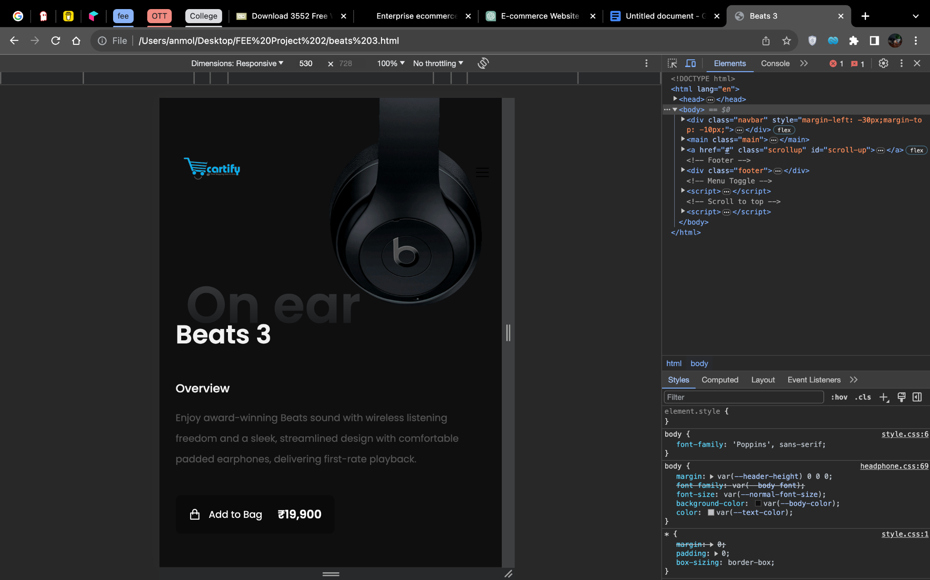

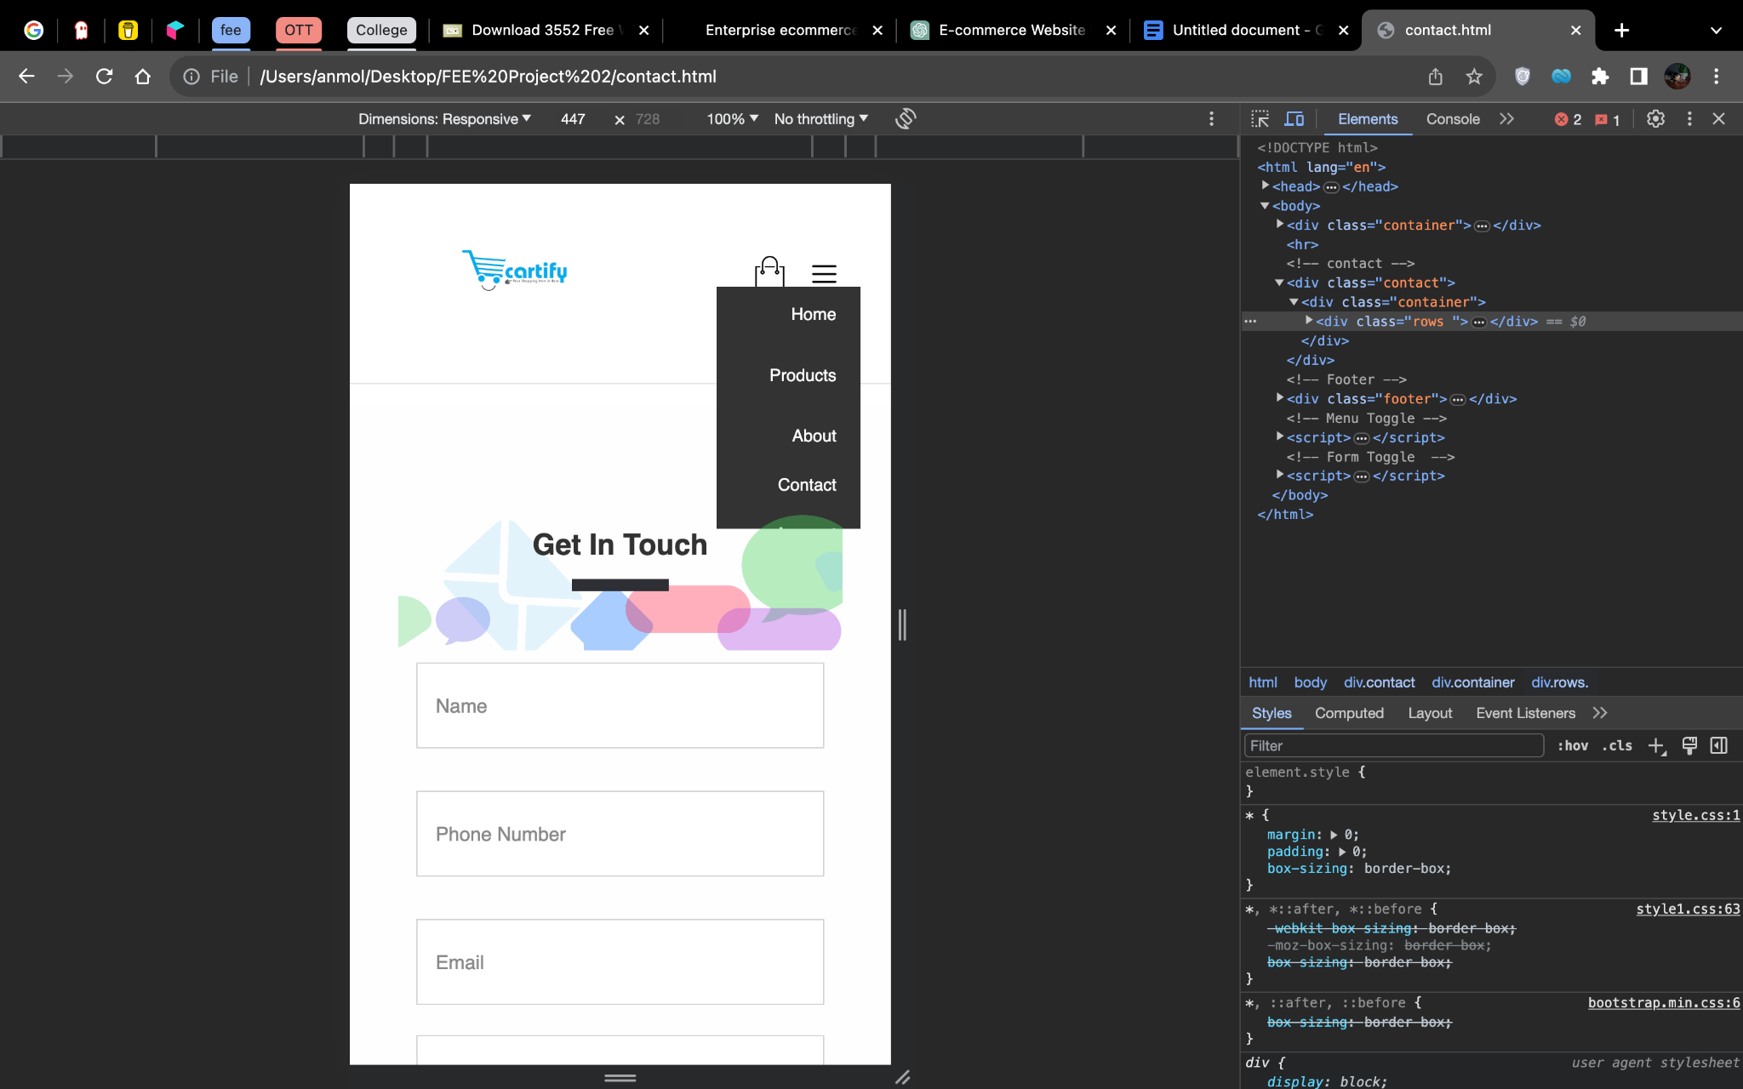

3. Architecture and Technologies Used:  
The Cartify website was built using the following technologies:  
a) HTML: The structure and layout of the website were created using HTML. HTML tags were used to define the different sections of the website, such as headers, footers, navigation menus, and product listings.

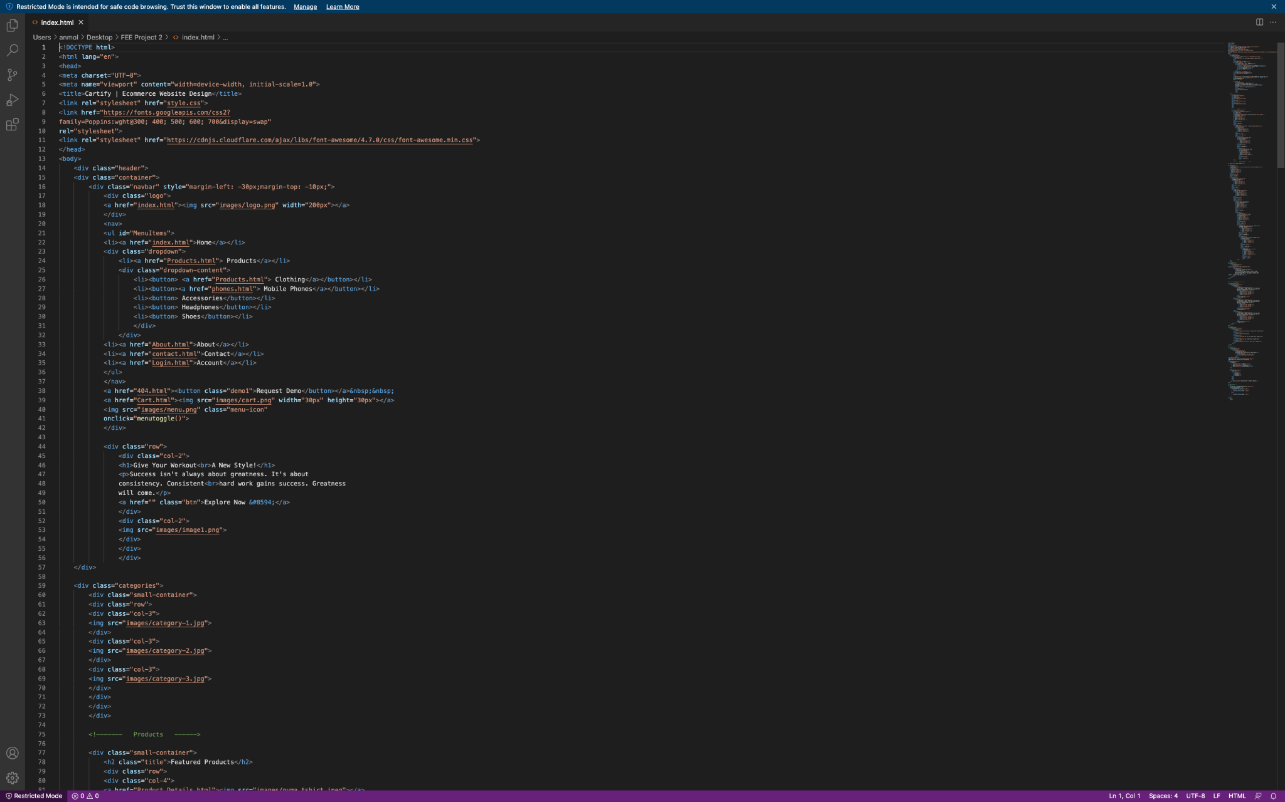 

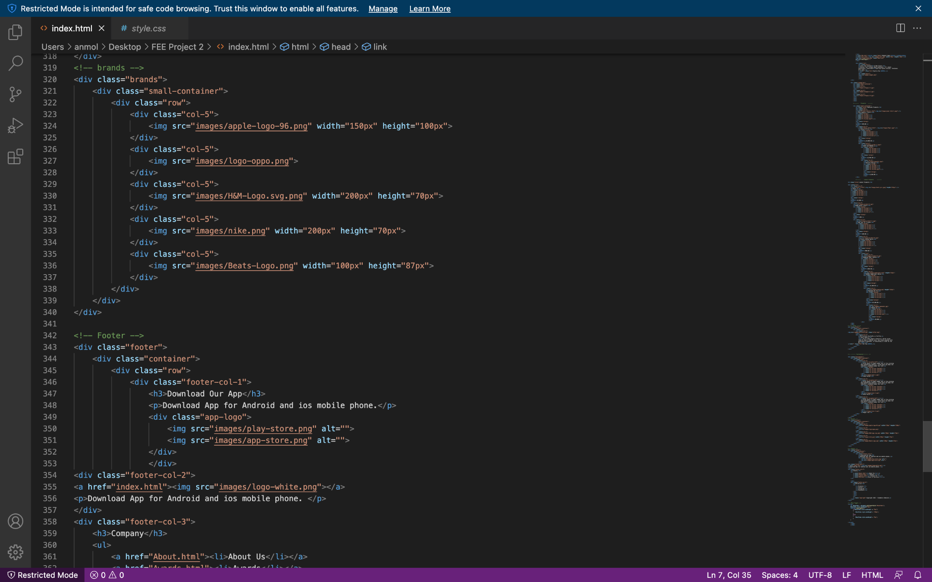

b) CSS: Cascading Style Sheets (CSS) were used to enhance the visual appearance of the website. CSS properties were applied to HTML elements to define colors, fonts, layouts, and other styling aspects.

 

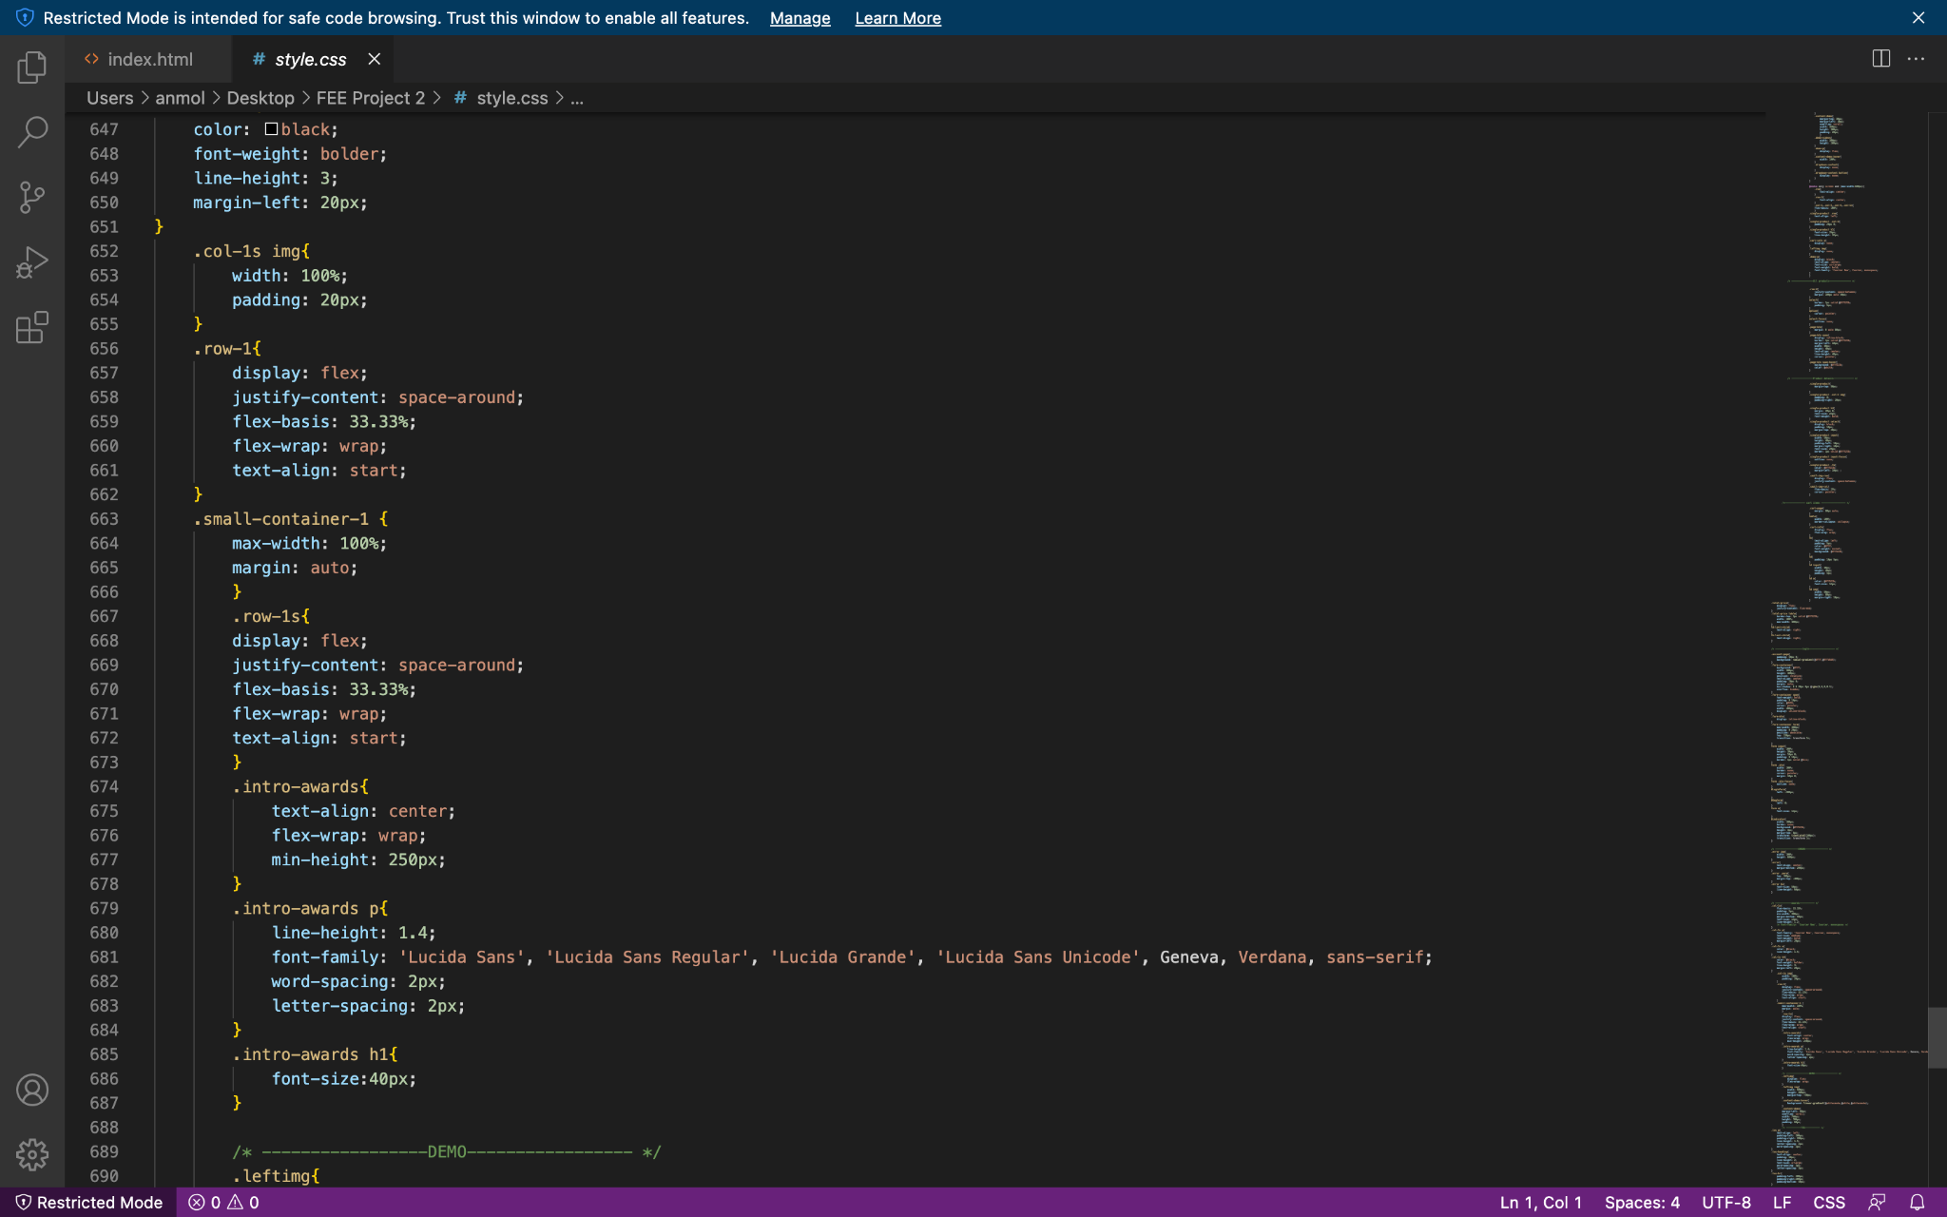

c) JavaScript: JavaScript was utilized to add interactivity and dynamic functionality to the website. It was used to handle user interactions, validate form inputs, perform client-side data processing, and implement features like product search and cart management.

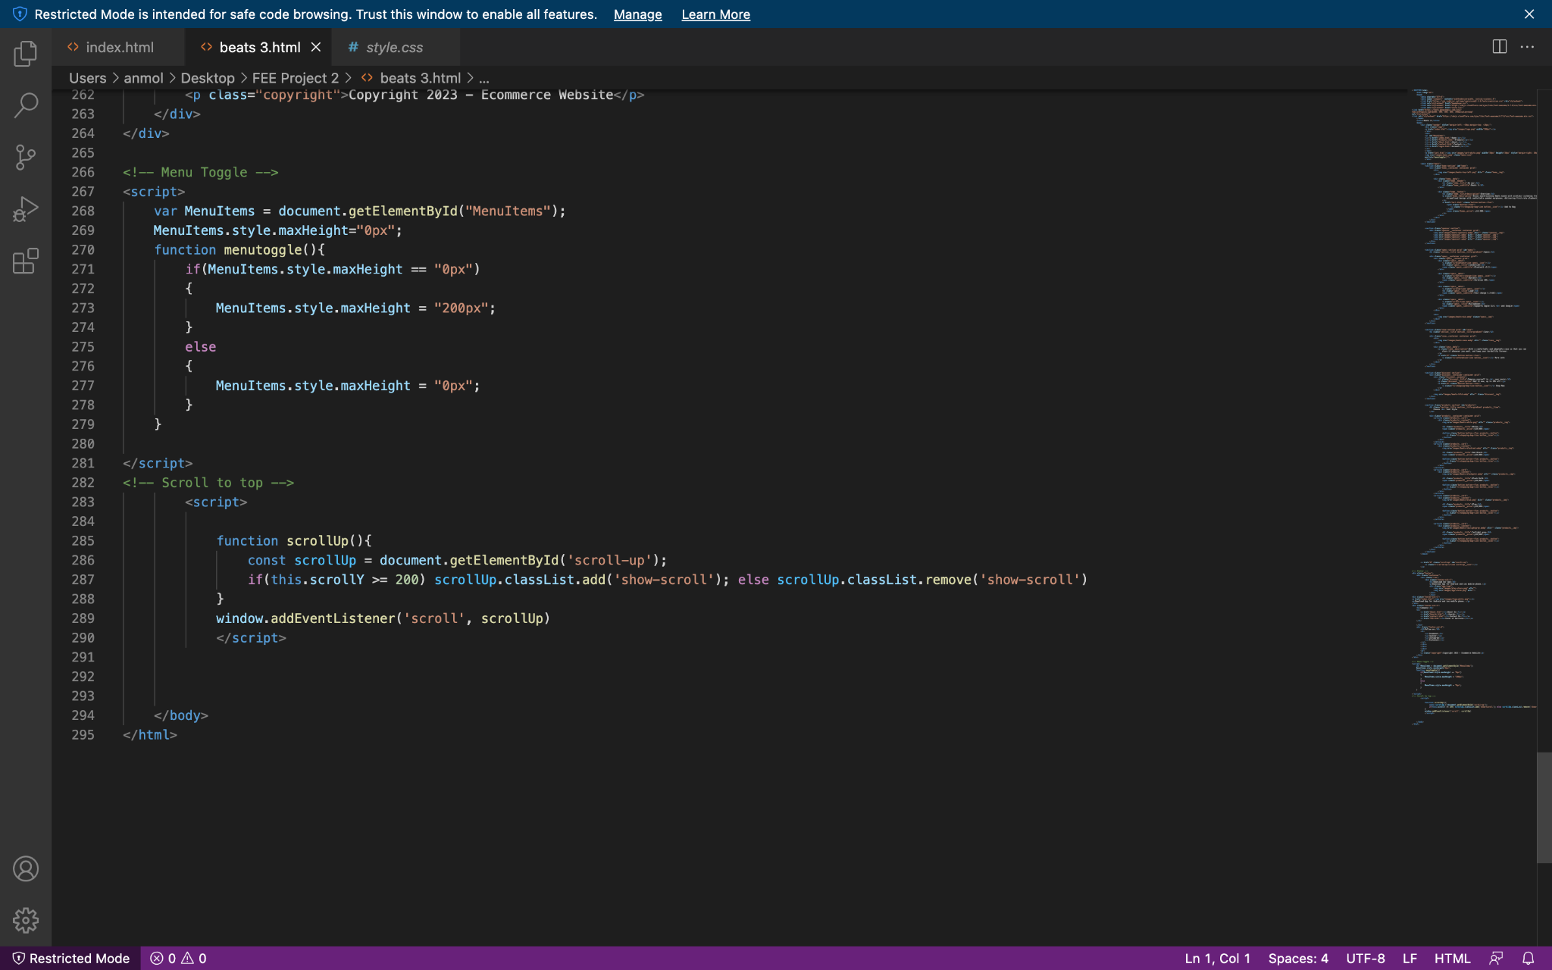

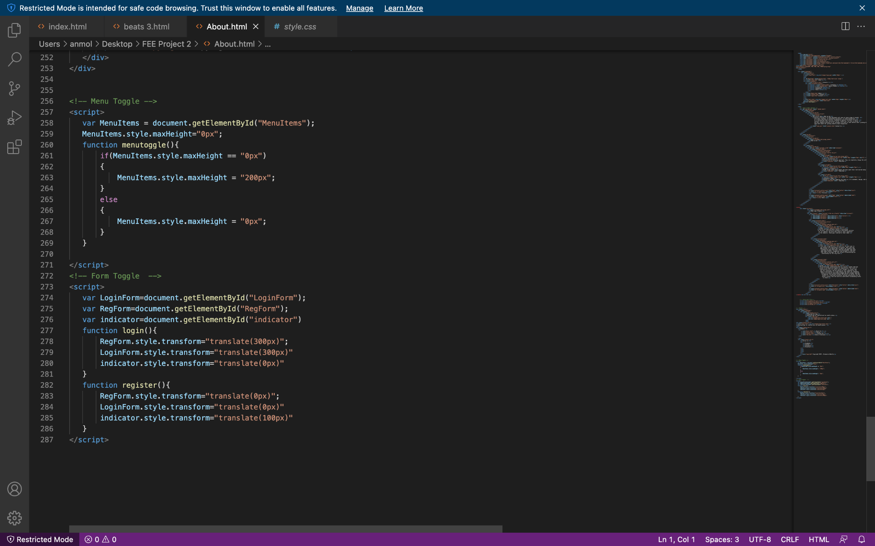

4. Features and Functionalities:  
Cartify offers a wide range of features to enhance the shopping experience. Some of the key functionalities include:  
a) User Registration and Authentication: Users can create an account on Cartify by providing their personal details. This allows them to securely login, manage their profile, and track their order history.

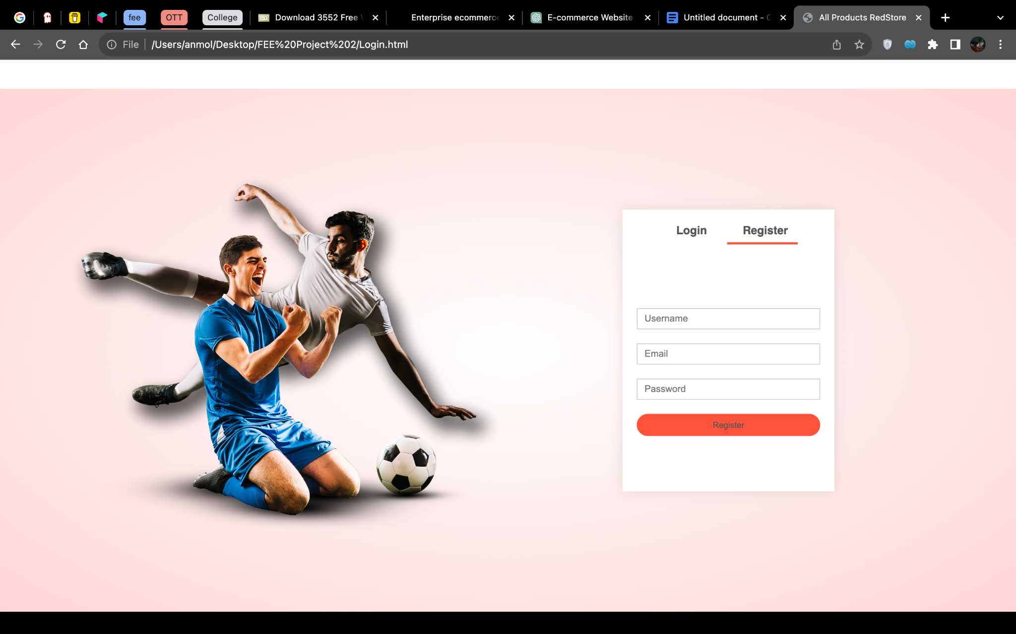  
  
b) Product Catalog: The website provides a comprehensive catalog of products organized into different categories. Users can browse through the catalog, view product details, and add items to their cart.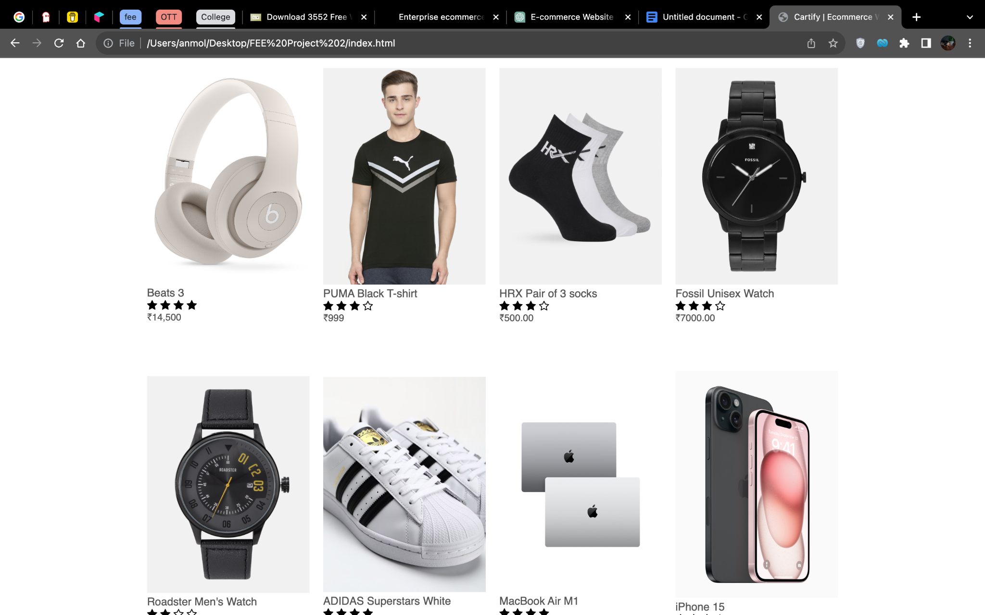

c) Cart Management: Users can add products to their cart, view the cart contents, update quantities, and remove items. The cart also displays the total amount and provides a seamless checkout process.

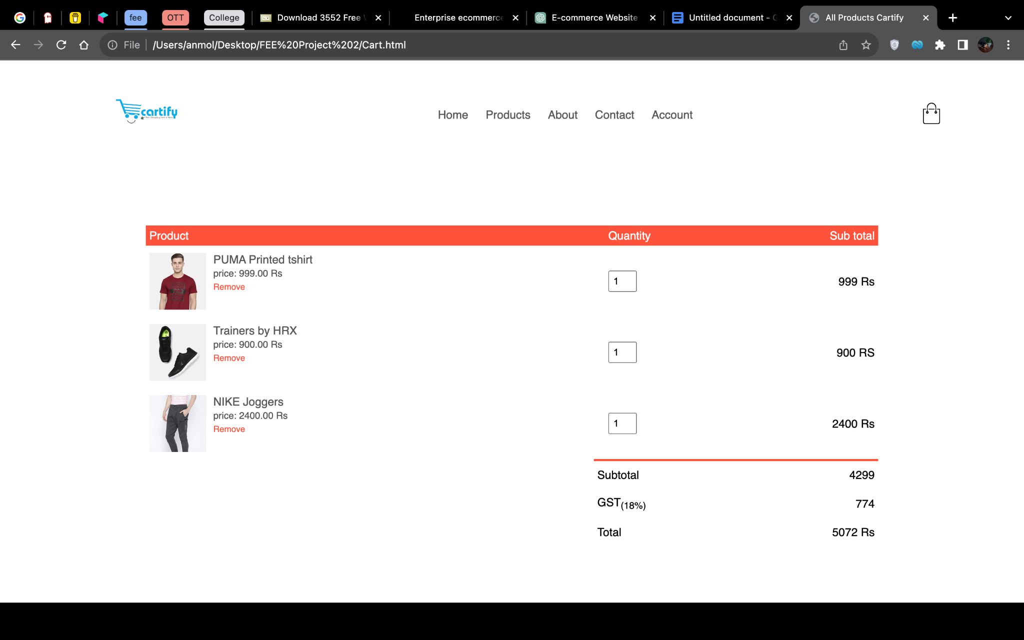

d) Product Search: Cartify includes a search functionality that allows users to quickly find specific products by entering keywords or filtering based on categories, brands, or other attributes.

e) Testimonials: Testimonials are a valuable addition to your e-commerce website, as they provide social proof and build trust with potential customers. Well-chosen and prominently displayed testimonials can help persuade visitors to make a purchase.

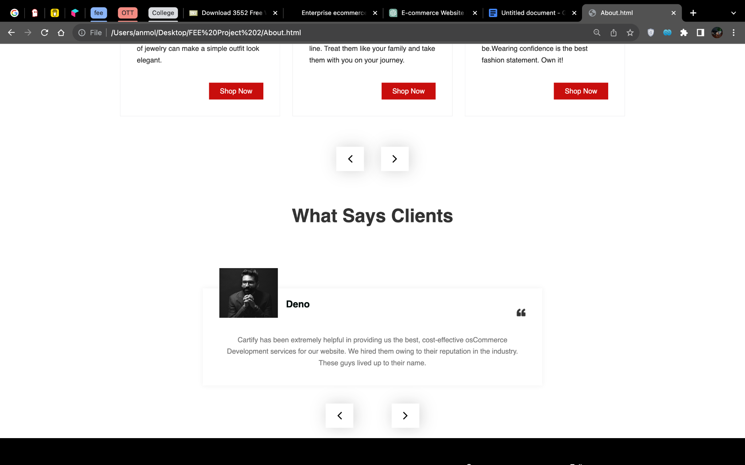

f) Order Tracking: Once an order is placed, users can track its status through a unique order tracking number. This feature provides transparency and allows users to know the progress of their shipment.

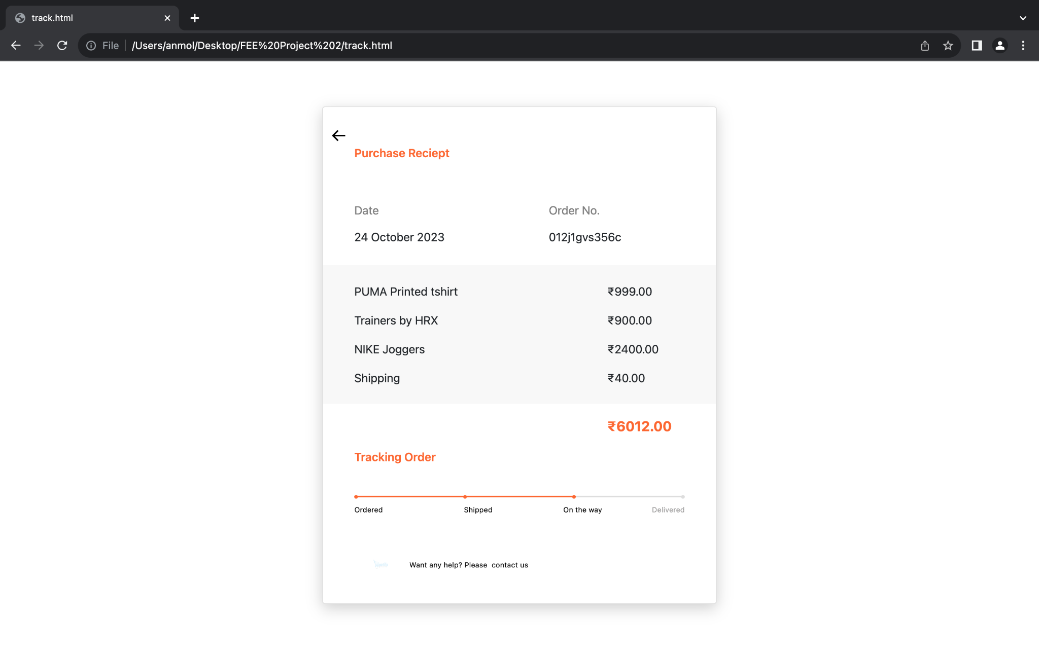

g) Product details: Product details are essential components of any e-commerce website. They provide potential customers with in-depth information about the products meoffer, helping them make informed purchasing decisions

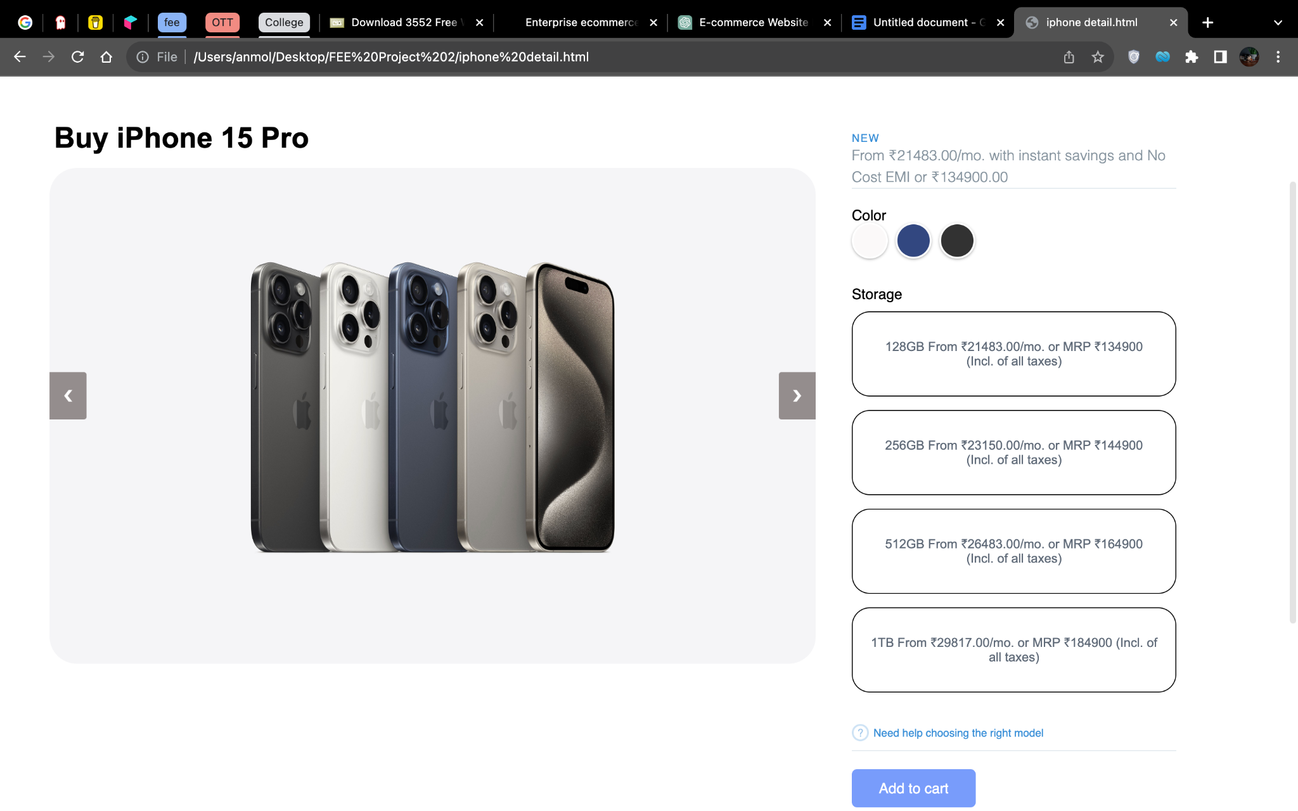

h) Awards: Awards and recognitions are a powerful way to build trust, credibility, and authority for your e-commerce business. They serve as a testament to the quality of your products or services, customer satisfaction, and the excellence of your company

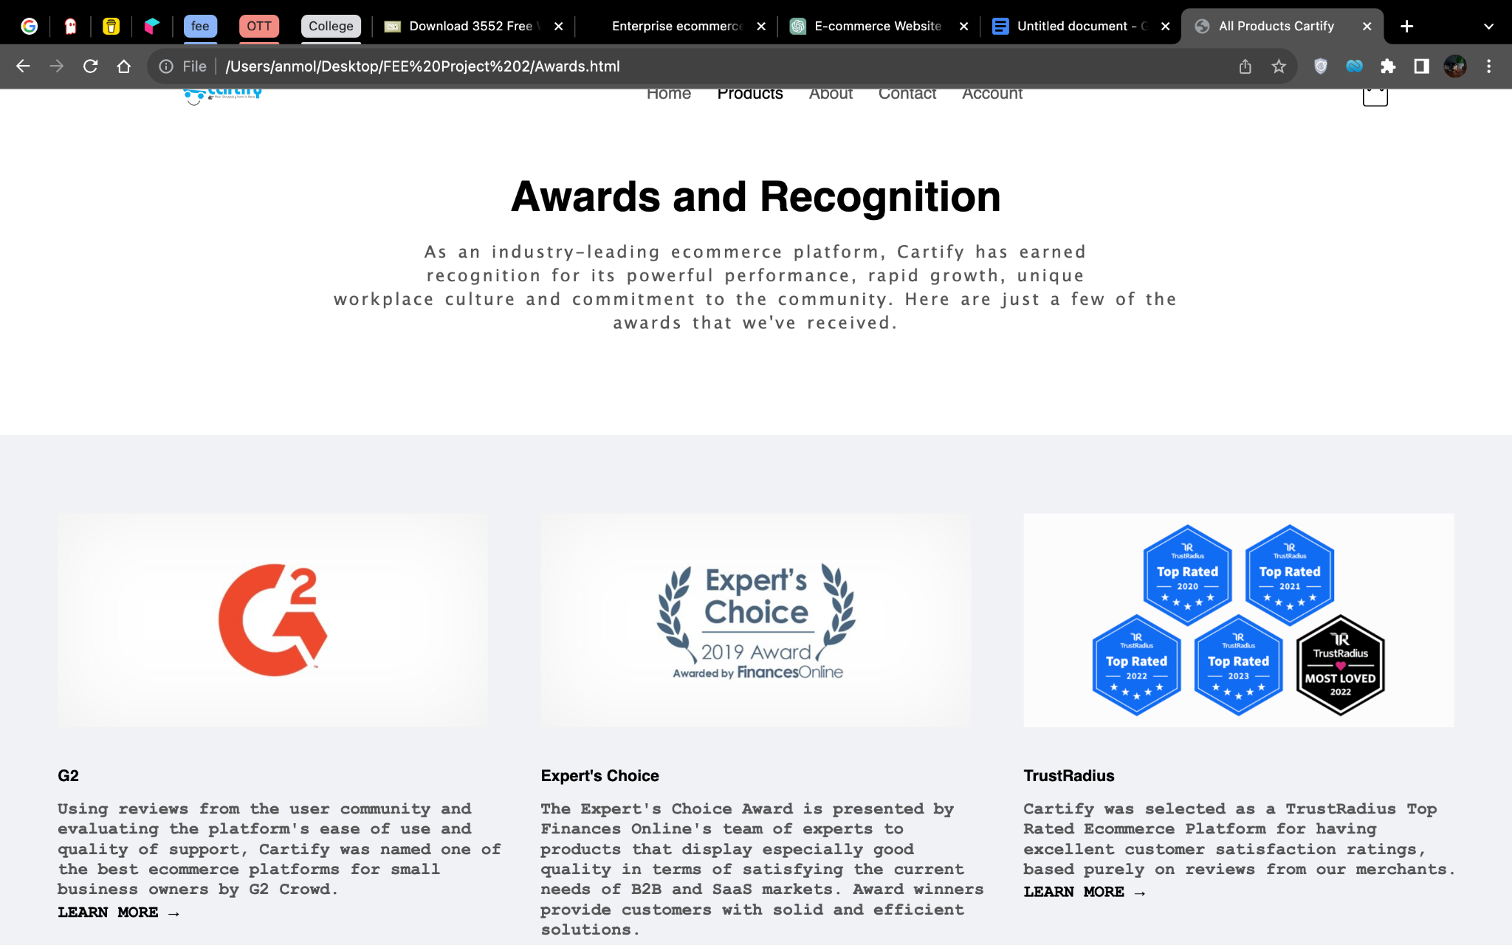  
i) Secure Payments: Cartify ensures secure online transactions by integrating with trusted payment gateways. Users can choose from various payment options and complete their purchases with confidence.

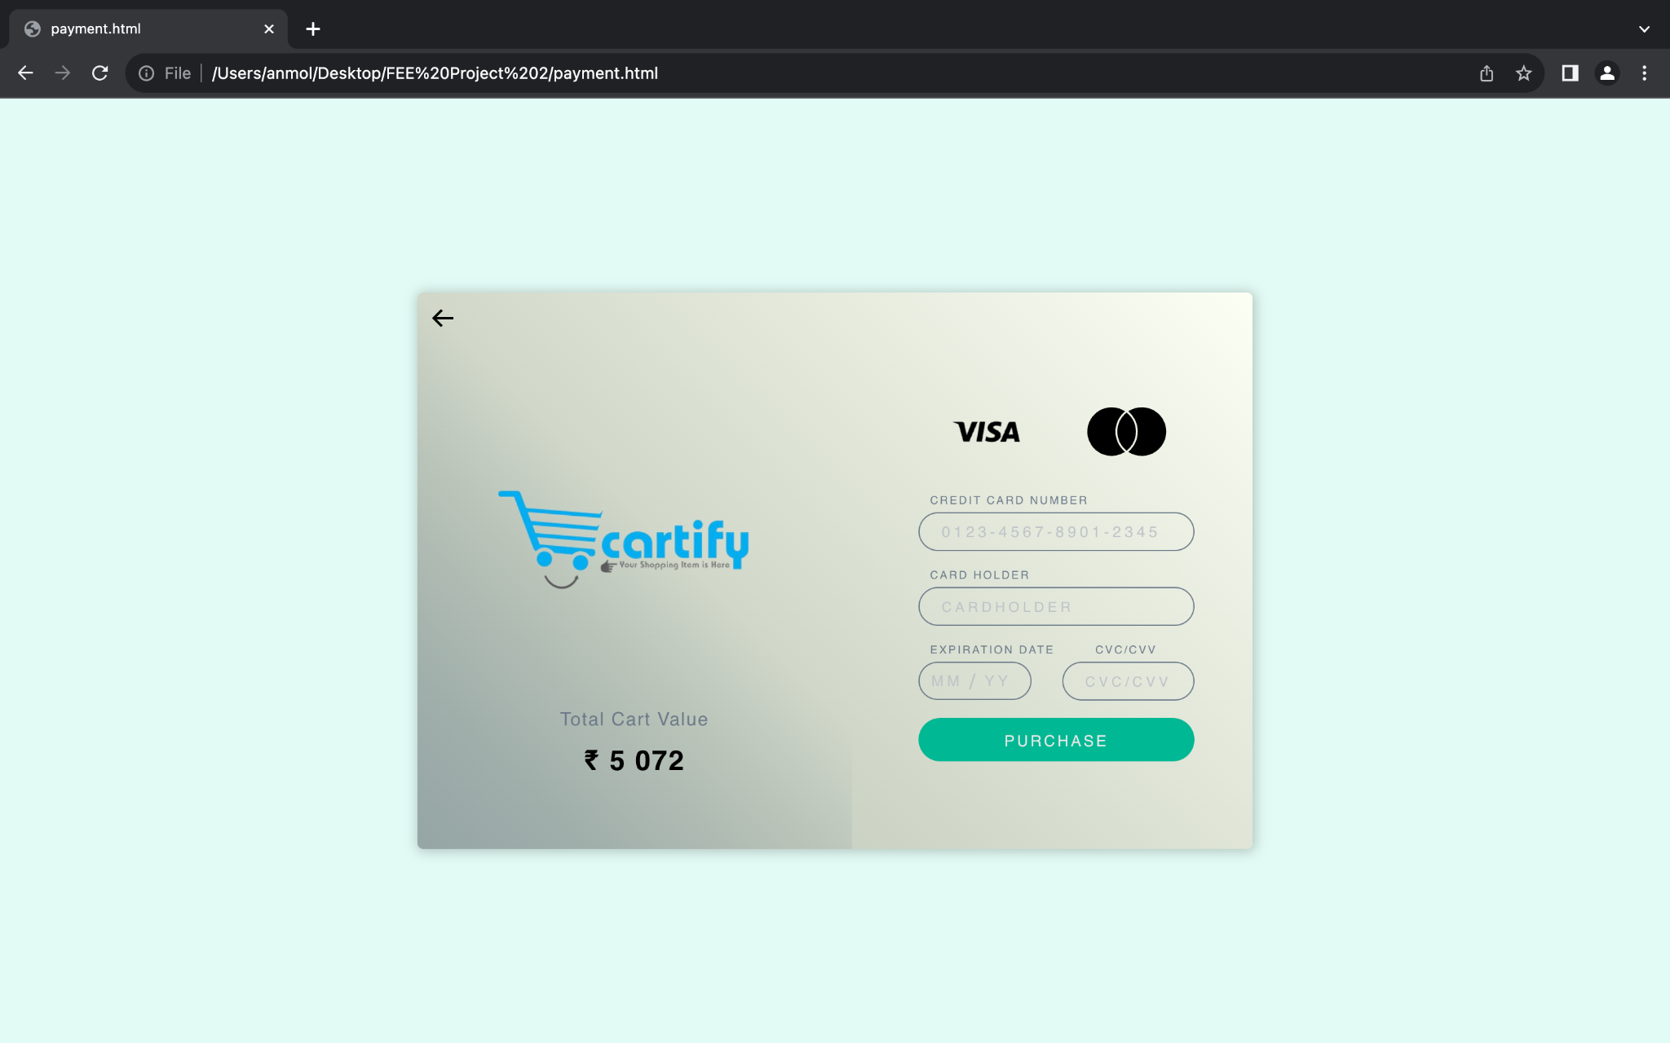

j) DEMO: Demo videos are an effective way to showcase your products or services to potential customers. They provide a visual and dynamic demonstration of how your offerings work and what benefits they provide.

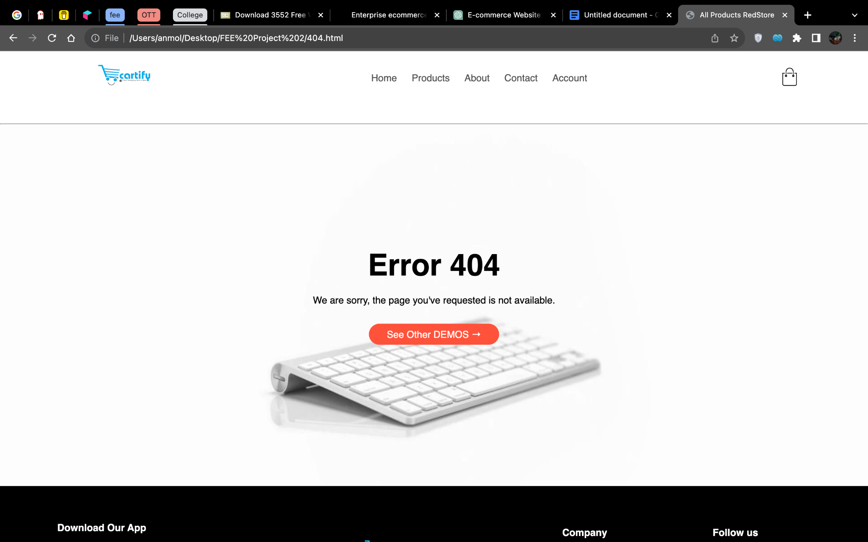

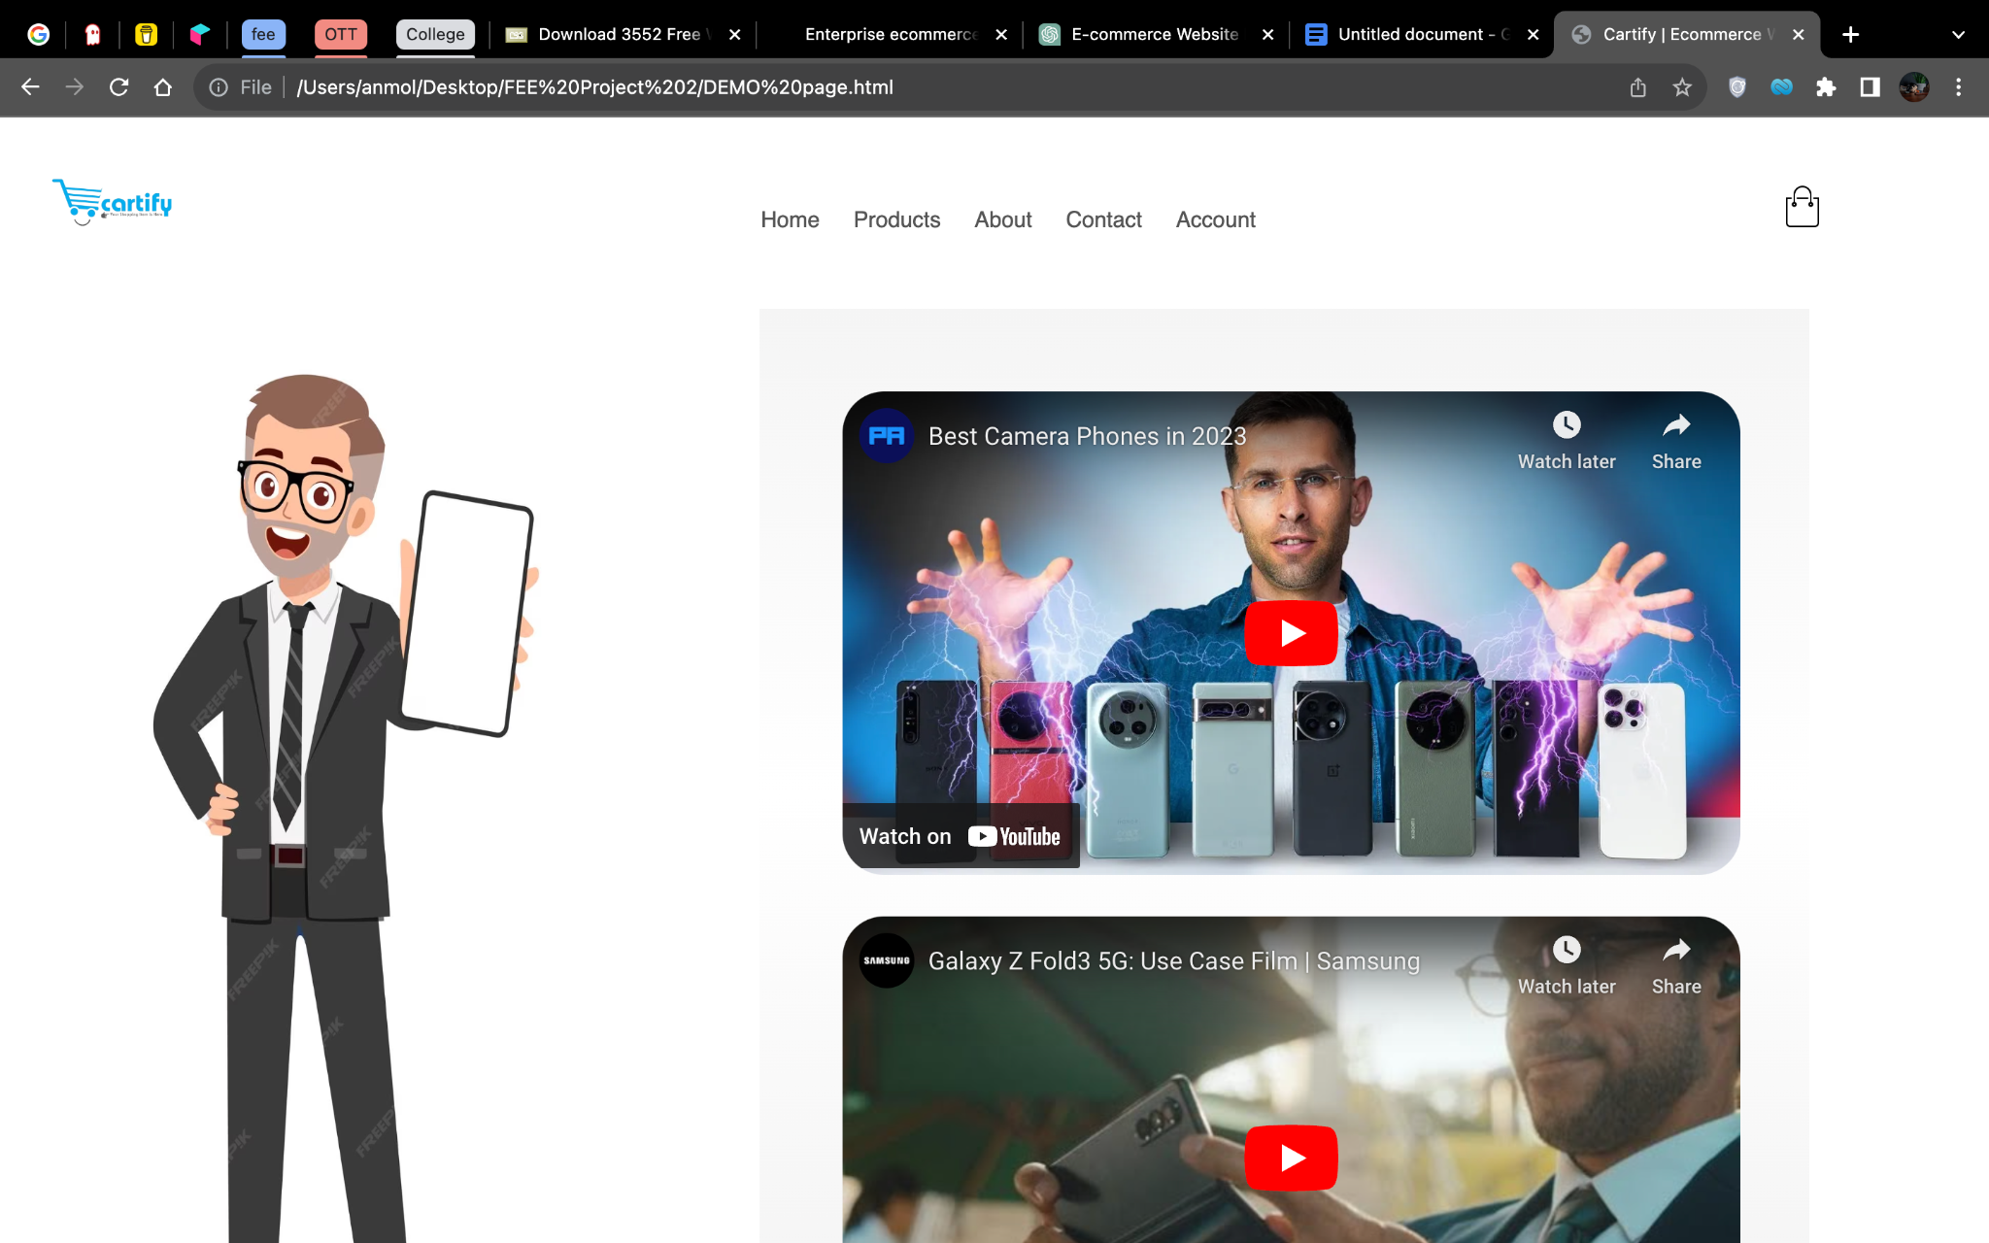

k) Terms and Conditions:The terms and conditions (or terms of service) document defines the legal relationship between the e-commerce website and its users. It covers various aspects, including user responsibilities, refund policies, dispute resolution, and more.

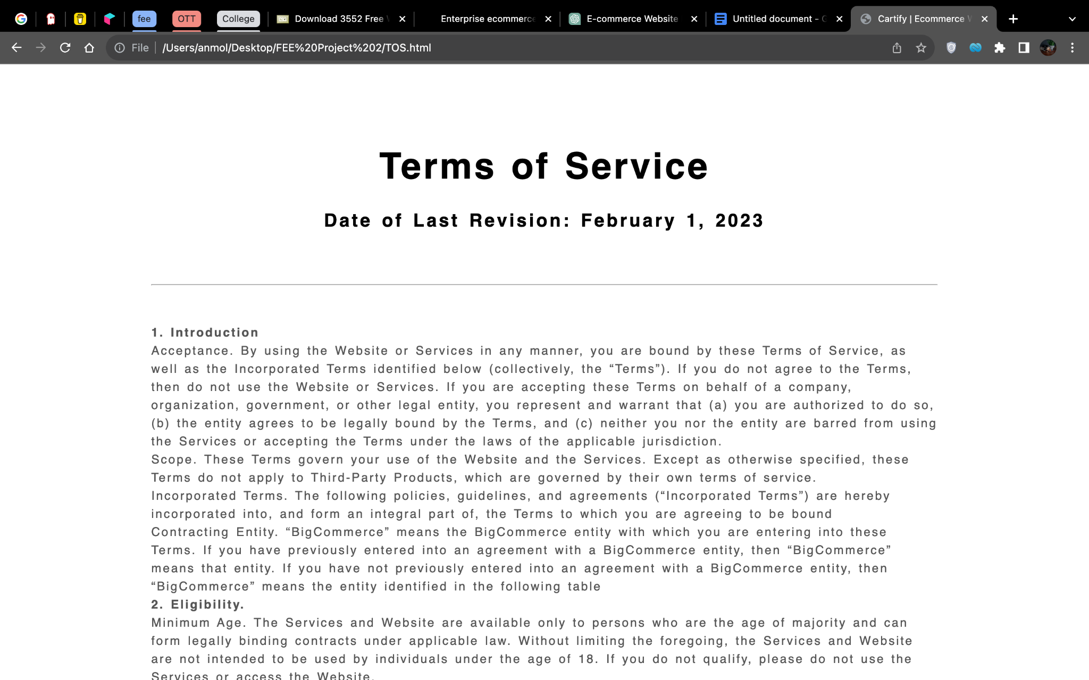

4.Challenges:

Creating an ecommerce website like Cartify using HTML, CSS, and Javascript came with its fair share of challenges.

a. User Interface Design: Designing an intuitive and visually appealing user interface for an ecommerce website was challenging. I had to ensure that the layout was easy to navigate, and product categories were well organized.

b. Responsive Design: With the increasing usage of mobile devices for online shopping, it was crucial for Cartify to have a responsive design. This meant adapting the website layout to various screen sizes and resolutions, optimizing image sizes, and ensuring smooth user experience on both desktop and mobile platforms.

c. Scalability: As Cartify grew and attracted more users, it was essential to plan for scalability. We had to ensure that the website infrastructure could handle increased traffic and transactions without a significant impact on performance thus making it a light weight website

d. Payment Gateway Integration: Integrating a secure and reliable payment gateway into Cartify was a significant challenge. We had to ensure that customers could make payments seamlessly, while also ensuring the security of their personal and financial information..

Despite these challenges, developing Cartify using HTML, CSS, and Javascript was a rewarding experience. Overcoming each obstacle allowed me to create a robust and user-friendly ecommerce website that provides an exceptional shopping experience for customers.

5. Testing and Quality Assurance:  
Throughout the development process, rigorous testing and quality assurance measures were implemented to ensure a bug-free and user-friendly website. The website was tested for compatibility across different browsers and devices, including desktops, laptops, tablets, and smartphones. Various testing techniques, such as unit testing, integration testing, and user acceptance testing, were employed to identify and resolve any issues.  
  
6. Conclusion:  
In conclusion, Cartify is a fully functional e-commerce website developed using HTML, CSS, and JavaScript. It provides users with a seamless and secure online shopping experience. The website incorporates essential features such as user registration, product search, cart management, and order tracking. The use of responsive design principles ensures compatibility across multiple devices. Overall, Cartify successfully meets the project objectives and offers a reliable platform for online shopping.